Contents:

1.Introduction

2. History of Lean Introduction.

3.Why Lean is used?

4. Principles of Lean Integration

5. Lean Implementation practices

6.Conclusion.

7. References.

Lean Integration An Integration Factory Approach to Business Agility

By: Mayuri Pandey

1. Introduction

Lean Integration is one of the prominent approaches, adapted by most organisations in the field of software development. The concept of Lean Integration arose with the continuous evolution of development in the industry, concerning deep understanding of the business and managerial aspects to make a system which gives values and importance to customer needs. There are various start-ups or organizations present , which have drastically failed due to large amounts of wastes of resources and not focusing on the needs of the customer. So, to achieve a successful impact in the development industry , organizations need to adopt some ways where minimal wastage of resources would be given a priority and focus solely on the requirements of customers. Thus, to achieve this , Lean Integration has acquired the highest importance in the recent era.

With the evolution of various products and implementation of lean in the software industry, there are two widely accepted styles of the solution of Lean Integration , these are classified as Process Integration and Data Integration, whereas Process integration can be briefed by process automation, where the state of each process needs to maintained independently of the underlying application systems, where users are mobilized as par the transaction of business.Data Integration is combination of core information originated by accessing data from distributed systems across the organizations, such that operations and decisions of business are improved.

Adapting Lean Integration leads to business benefits as it intends to provide solutions focussing on the needs of the customers. In an organization Lean Integration can be achieved following the principles of Lean given by Toyota. It eliminates everything which adds non profit values to the organization.

2. History of Lean Integration:

The history of Lean started back in mid 1900’s, when Toyoda Sakichi, the founder of Toyota Motor Company, discovered the automobile manufacturers of America were more productive than Toyota and Japan’s auto market being smaller than U.S , which in turn making them realise that their production system is not up to the mark to compete the market standards of high variety but low marketing standards of Japan. All these realizations led them to a fundamental thinking that to stay competitive in the production line, all wastes needed to be eliminated. These wastes included extra waiting time between time processes, overproduction etc, hence by eliminating these, they would be able to compete with the American car industry.

Taiichi Ohno firmly believed that the whole value stream needs to be improvised to achieve the objective of providing customers with valued services. He also identified nine principles to support his radical thinking and that clearly briefs why lean management is needed. The first principle talks about meeting customer expectations and reducing the cost. It can be achieved by improvising the knowledge of people concerned with developing and working on new solutions for the customers. The second principle is to assure that a continual increase of customer value is done. The third principle is stream monitration and eliminating all wastes from the first supplier to the end user. The fourth principle identifies all kinds of waste that can coexist in the process and eliminates them by the seven waste methodology. The fifth talks about the event flow which takes place from the initial development phases and until the final product is received by the customer. The sixth principle states spending more time in system monitoring of the process and making predictions about theories of what possibly can go wrong. The seventh principle is visualization of the whole lean management system and making it transparent from all levels in the team. The eighth principle focuses on communication between leaders, suppliers, team members and the managers and teamwork. The ninth principle is confined to product improvement by creative solutions and seeking perfection in everything.

3.Why Lean Integration is important

The main aim of Lean Integration is to increase revenue and profits, reduce the time that is needed for the product development and reduce the cost so that the final product would be promising and can hit the market. While developing a product the organization can face innumerable challenges to achieve the above mentioned goals. The few problems that the organizations can encounter are weak communication inside the teams and worse team engagement which in turn can lead to slow response time and thereby can cause huge money cost and time loss, and efforts in waste.

If any organization adapts Lean Integration a high elimination of waste and huge revenue can be achieved as each process and steps are being thoroughly observed with effective solutions, which is a continuous level of that which needs to keep going throughout the whole process, so as all the goals of Lean can be achieved. Lean Integration is a widely accepted concept because it includes management of team and the processes , increasing productivity of teams, a better visibility of process at team levels, reduces lead time, it also helps in making efficient business planning and improves stakeholders visibility as a whole.

4. Principles of Lean Integration

To have a better understanding of Lean as a whole the principles need to be comprehended. Lean Integration principle is the most important part of the whole integration process of Lean. The process of Lean principles is a continuous process which needs to be implemented throughout the life cycle of the project to achieve higher efficiency.It needs time and effort and once achieved, can lead to value added product at the end. Each principle is briefly explained below: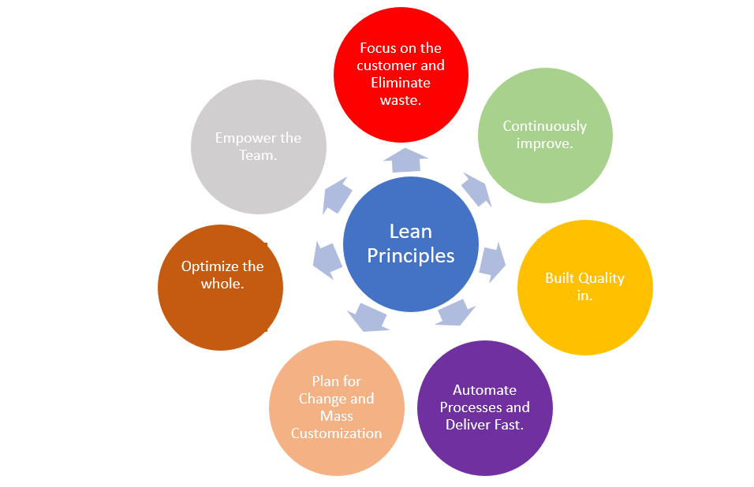

Fig: Principles of Lean [1]

4.1. Focus on the customer and Eliminate Waste

The first principle focuses on customer value and eliminating the waste. Value is what the customer is paying for. As customers are the most important part of the process so understanding their requirements is necessary. The end product needs to ensure that it adds value to the customers, and all the requirements are being clearly understood, else it will add to an unnecessary wastage of resources and overproduction.

The second section of the principle is about waste elimination in the organization. There are multiple possible sources of waste production for example, Overproduction can result in waste in the form of extra features that the customer did not request or the production of a function in the hopes that it will be used. Transportation waste refers to any waste generated as a result of the unnecessary movement of any material during the development process. Over-processing by redoing the process and reconsidering decisions can cost time and effort, which is a significant waste that must be eliminated in the process, as well as time and effort spent fixing defects that could have been avoided etc.

4.2. Continuously Improve

Lean Integration mainly focussed on continuous improvement since the beginning of the development phase, as there are high possibilities of errors and risks concerned with each phase. This is no way possible to develop a perfect product from the beginning. New and updated techniques and methodologies should be adapted by the organization to keep up with the competitive market. As far as quality is concerned , old techniques have a high possibility of getting obsolete with time. The whole team’s knowledge building and learning is necessary to push them to do a radical thinking which can in turn enhance the product quality and performance.

4.3. Empower the team

The team plays a crucial role in the field of Lean Integration. Each member of the team should contribute individually and be able to express their view explicitly, no matter how small that idea is, the leaders should always encourage the team members to participate . Each member of the team matters and holds equal importance. The word Empowerment means empowerment of the product creator which in turn leads to the improvement of the overall product. The leaders and managers should also provide feedback for each idea being presented, so that it can encourage them and push them forward with new ideologies in future without any fear. Each contribution of the team member should be monitored to make sure each team member is contributing and providing their maximum efforts. A higher level of transparency should coexist between the teams and the leaders. The team members should be able to put their views forward without the fear of higher officials.

4.4. Optimize the whole

This principle focuses on the overall system and not only just the subparts. Deterioration of the system is one of the reasons why the whole system needs to be optimized, hence adding customer value. Value mapping and metrics are used as careful review and improvement of the subparts needs to be done such that there is negligible possibility of collision between the system, hence value mapping and metrics to ensure the efficiency of the improvements.

4.5. Plan for Change and mass customization

A proper planning should be carefully done which can occur due to some change thereby causing any abrupt efficiency in the system. The prediction of the results of the change should be done to avoid risks in future. There are few steps which can be taken and also helps in planning the changes, the first step is ensuring each pieces are independent, and does not depends on others, and any change will not affect the overall system.The second step is making the changes reversible in nature by designing it in a proper way from the start, and hence updating documentation after all the changes that takes place.

4.6. Automate processes

Automation mainly focuses on maximum productivity, efficiency, quality.[2] Automating the process means avoiding obsolete practices and focussing on methodologies that can speed up the process with better results, hence increasing the overall system.The key to a successful use of automation therefore lies in finding, selecting, acquiring and properly implementing the right type and level of automation in relation to the company’s needs, goals and prerequisites. [2].

4.7. Build quality in

The data quality plays a crucial role in the development system as it is being used at each step.

5.0 Implementation and Execution

The implementation and execution states the means and methods so as to achieve the lean integration.

5.1 Financial Management

This part of the process is responsible for taking care of the financial state of the organization and its stability during the entire lifecycle of development. Following steps are important with regards to financial management;These are: Clarify Business Need, Identify Options and Define Approach,Determine Costs,Define Benefits, Analyze OptionsEvaluate Risks, Package the Case,Present the Case. Review Results

5.2 Integration Methodology

The integration methodology deals with the integration between different parts and its effect on the data quality of the organization. The integration methodology requires certain steps which need to be implemented correctly. They include; Implement Integration Competency Centers, Define Enterprise Standards, Select Project Methodology, Transition Project to Integration Competency Centers, Maintain Metadata, and Control Configuration Changes.

5.3 Metadata Management

Metadata can be defined as information about the data itself. To simply, it can be considered as the blueprint of the data which can be useful to track the data flow through integrated parts. This proves to be highly useful in the event of data misuse or incorrect editing. For metadata management system establishment, following steps are important; Identify Value Proposition, Define Metadata Services, Architect Metadata Solution, Install & Configure Repository, Execute & Optimize Processes, Define Sustaining Processes, Develop External Interfaces [1]

5.4 Information Architecture

The goal of establishing an information architecture in the lean integration approach is to concise and make use of only useful information from the data that the organization has as it is not necessary that entire data is of use along with the information.Basically, two steps are needed to be followed to implement the information architecture. These two steps can be divided into one-time effort activities like Organize Governance Committee, Define Governance Framework, Develop Reference Models, and Assign Organizational Roles and project specific activities such as Scope Program, Assess Baseline & Data Quality, Develop Target Architecture, Plan Migration Road Map, Develop Program Models, Implement Projects [1].

5.5 Business Process Management

BPM is useful in inputting the data in right places within the organization which in turn helps in producing an efficient process. This also helps in eliminating potential waste in the form of misuse and misinterpreted data. The activities included are process modelling, simulation, execution, monitoring, and optimization. BMP is responsible for betterment of governance of the products in each step. This leads to improved efficiency and quality of the product.

5.6 Modelling Management

Modelling management creates a communication channel between the stakeholders and the IT team. It makes use of graphical visualization technique for the entire system> During this, a protocol needs to be established between both the sides so as to ensure correct communication without misunderstandings and misinformation. [1]

6. Conclusion

The Lean Integration process as a whole adds a new meaning to the development of the projects if implemented continuously. This concept was actually implemented and designed to help and support the organization to have a continuous improvement in the process of Manufacturing. Using this method, small and incremental changes in processes will be sought to improve efficiency and quality of the product in the longer run. It will improve the process, with more revenue , reducing the cost and a good qualitative product eliminating waste and also make coordination between the different levels of hierarchy involved in the process. Lean Integration makes sure that the integration went smoothly, and all of the integrated parts are working properly. Due to its huge advantages it is mostly adapted by most of the industries.

7. References

[1] David Lyle, John G. Schmidt. Lean Integration: An Integration Factory Approach to Business Agility.